“Pivot call market depth

Prev day range symtoms 1 Gaps up 130 or 200 points but falls down towards prev day close and struck within high .low close of prev day

19. when ever price creates a spikes or long wicks near at  support or resistance for downward or upward moment , it mans there is a strong rejection in that direction , so in order to enter a new position in that direction wait to

wait for price to close above those rejection levels now you can mark the vwap and sma rule“

# Shooting Star

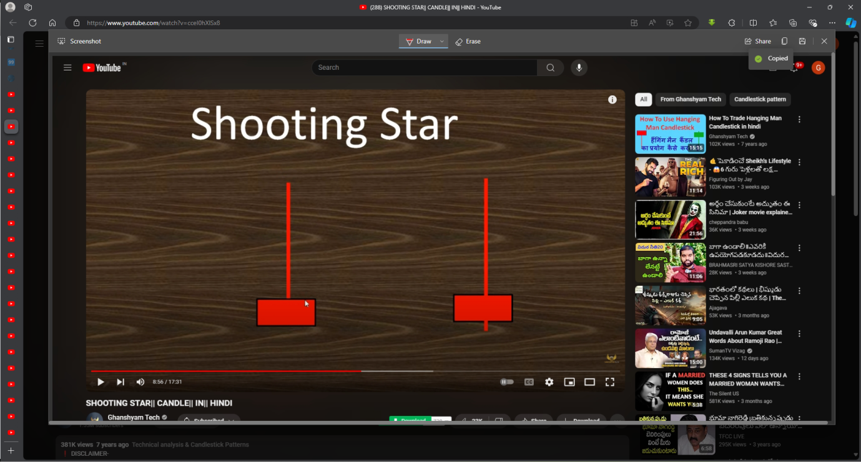

1#Shooting stars opening should be above previous candle close at top(gap up)

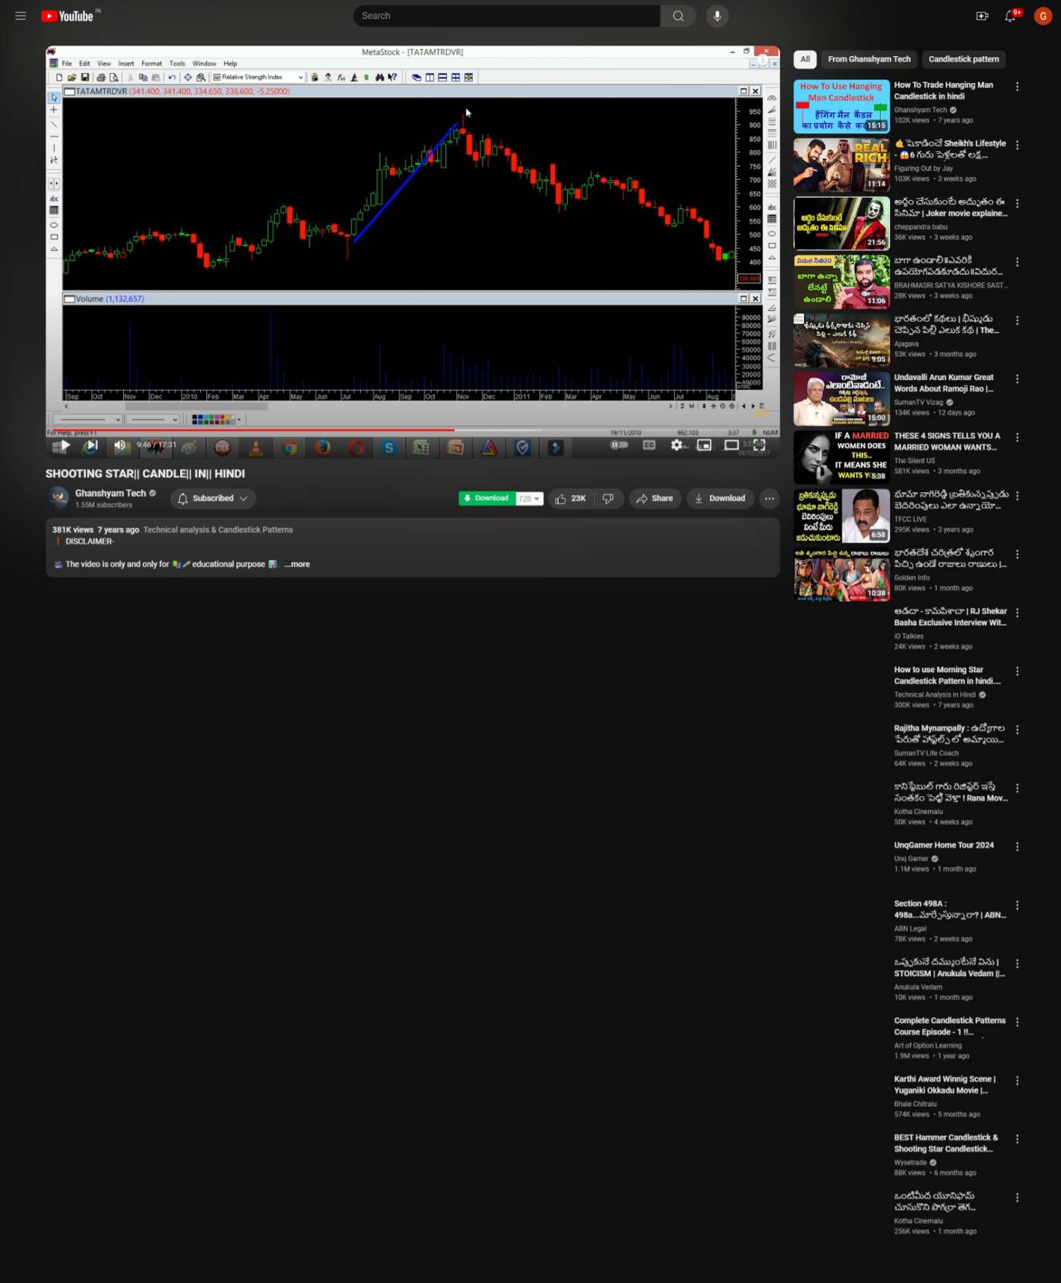

2# a)Next Candle that forms after shooting star ( shooting star at the top) to be opened gap down , that is if bullish shooting star , gap should be between shooting stars open or low and next candles open or close ( check below and above images )

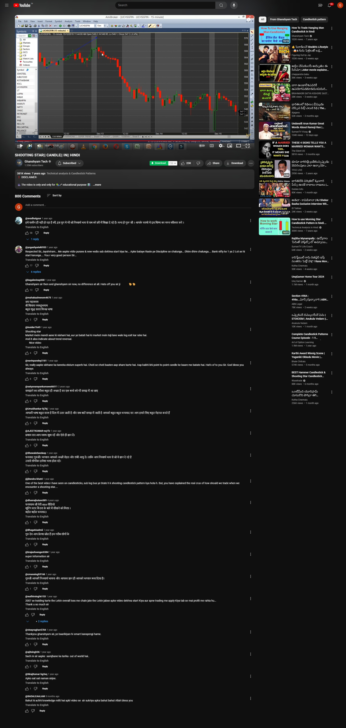

2# b) If bearish shooting star , gap should be between shooting stars close or low and next candles open

3 we will enter pe buy trade only if the third or longest body candle formed during uptrend is broken in downward trend

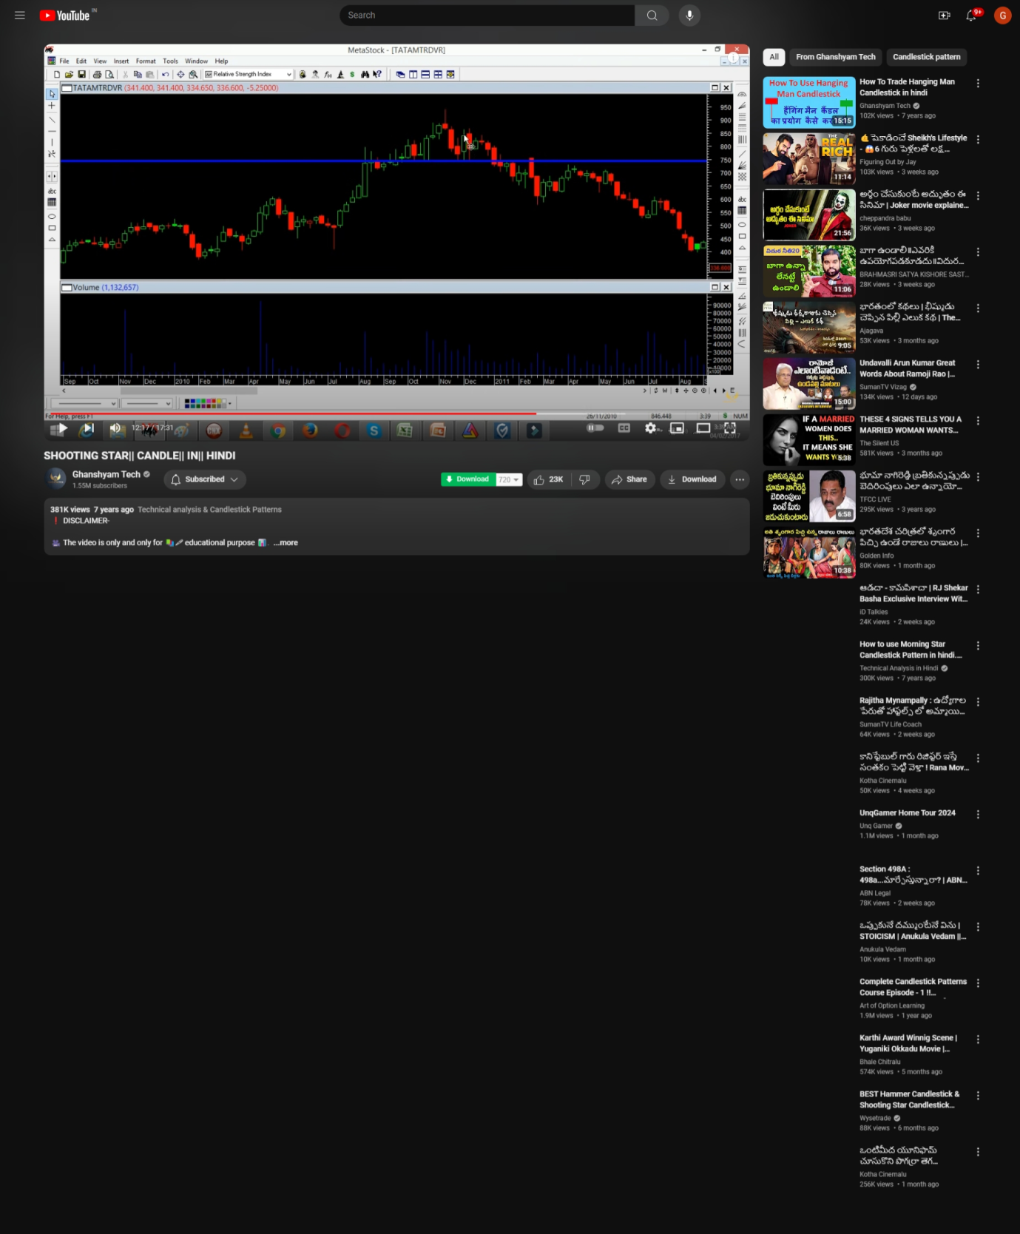

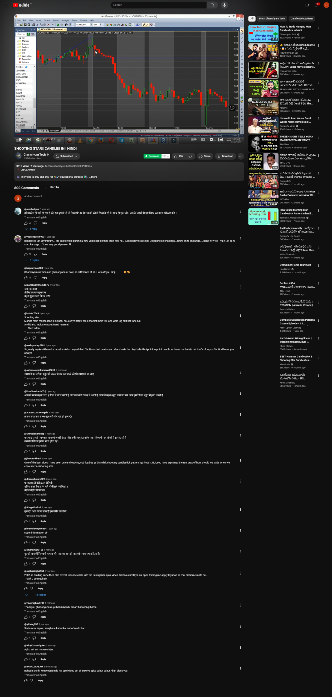

And

3b# stop loss will be shooting stars high ( so need to store details of shooting star)

4 a# When candle makes a new high after our trade entered point but below our entry point and below our stop loss point which is high of the shooting star , BUT again makes down trend then the stop loss will be the new high

4b# if again during the down trend if (2nd new high) is made after a low as part of continous downtrend , but is lower than our previous new high (1st new high), however contionous again down trend again , then this 2nd new high is our stop loss from here and so on

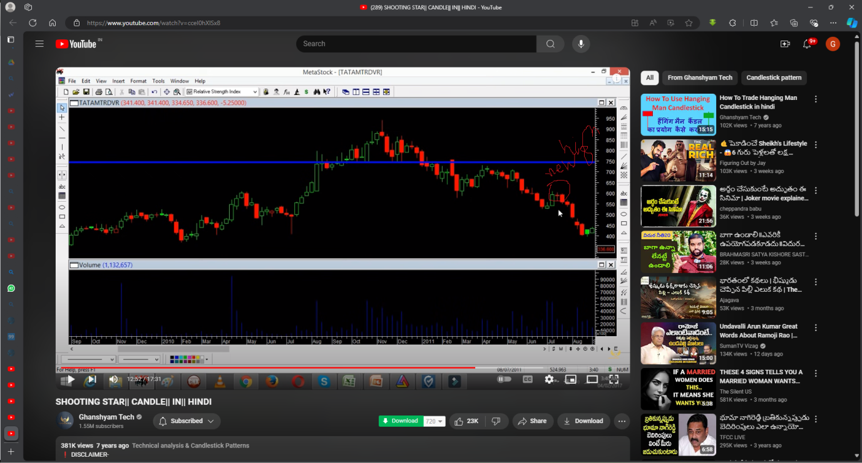

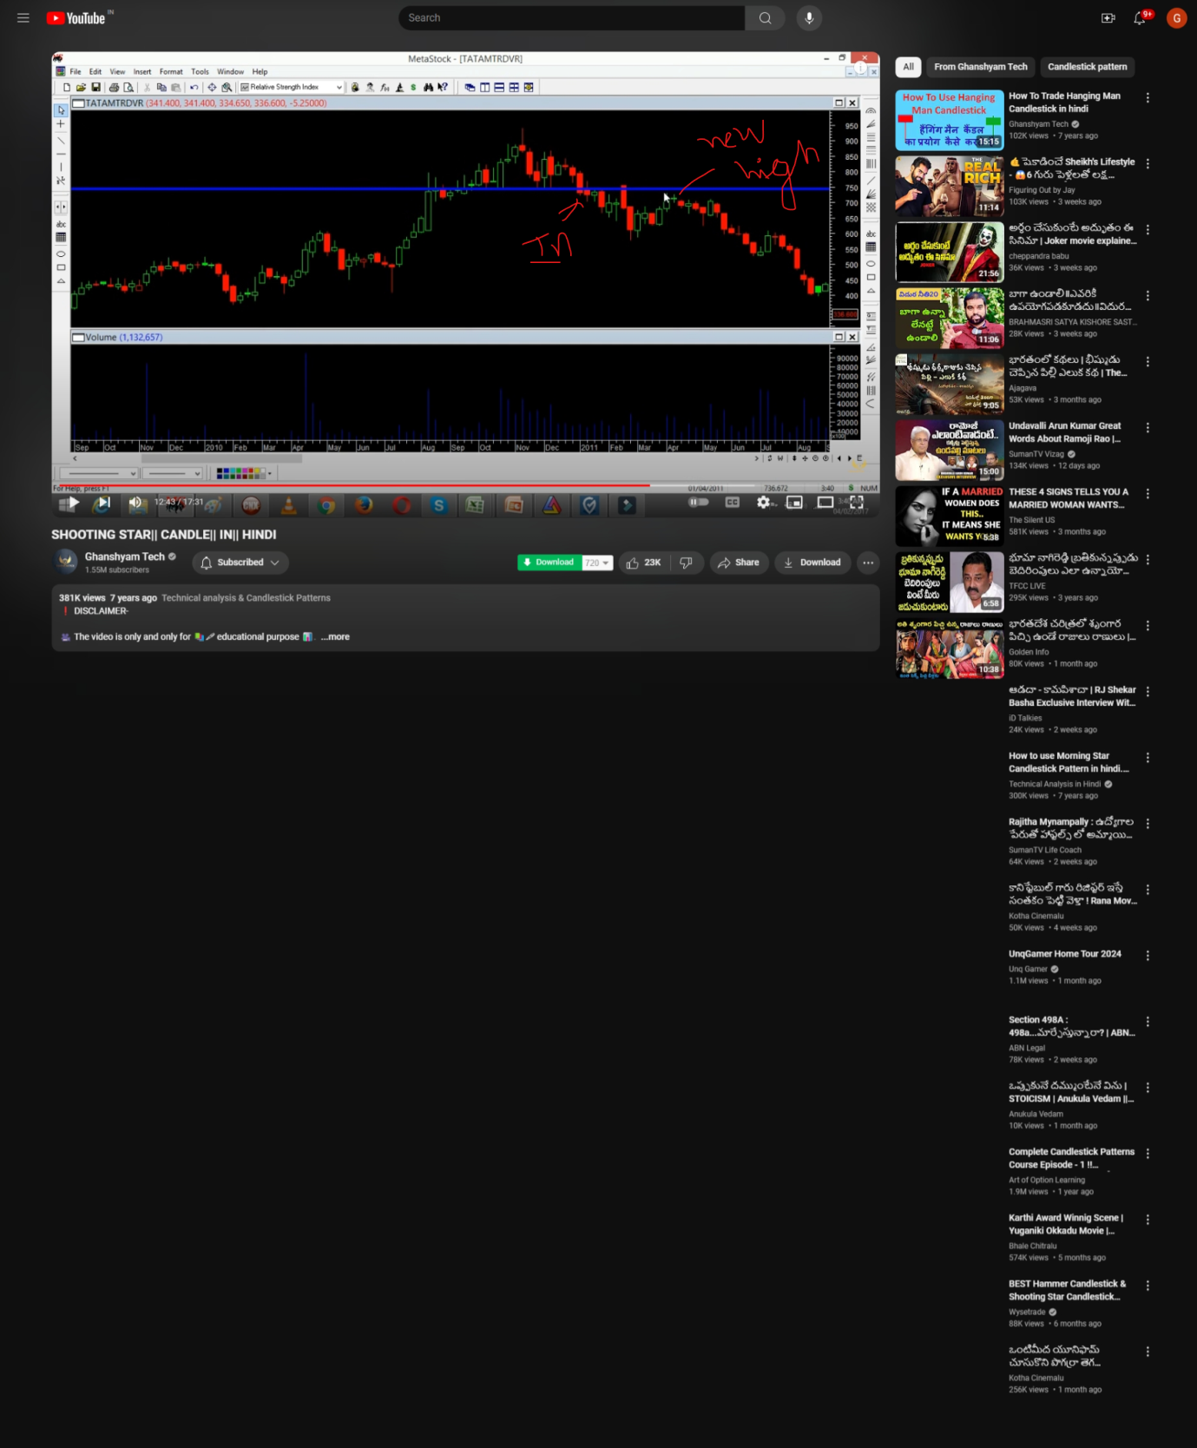

And before continouing or exit check a condition to see if price moment has slowed down in your trades direction and hence exit ( this is one of the exit conditions along with fib and cpr and gahanshams shooting stars stop loss point )

Hammer and inverted hammer :-

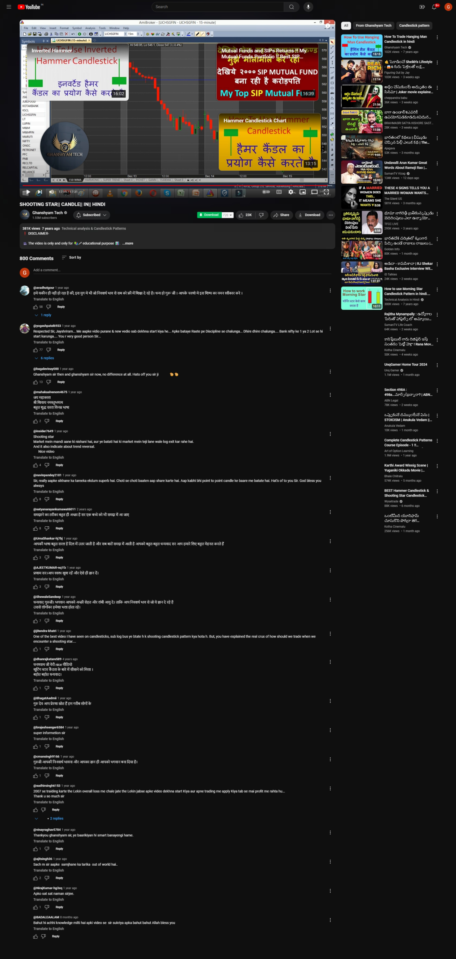

# Hammer Pattern:

Hammer forms at bottom

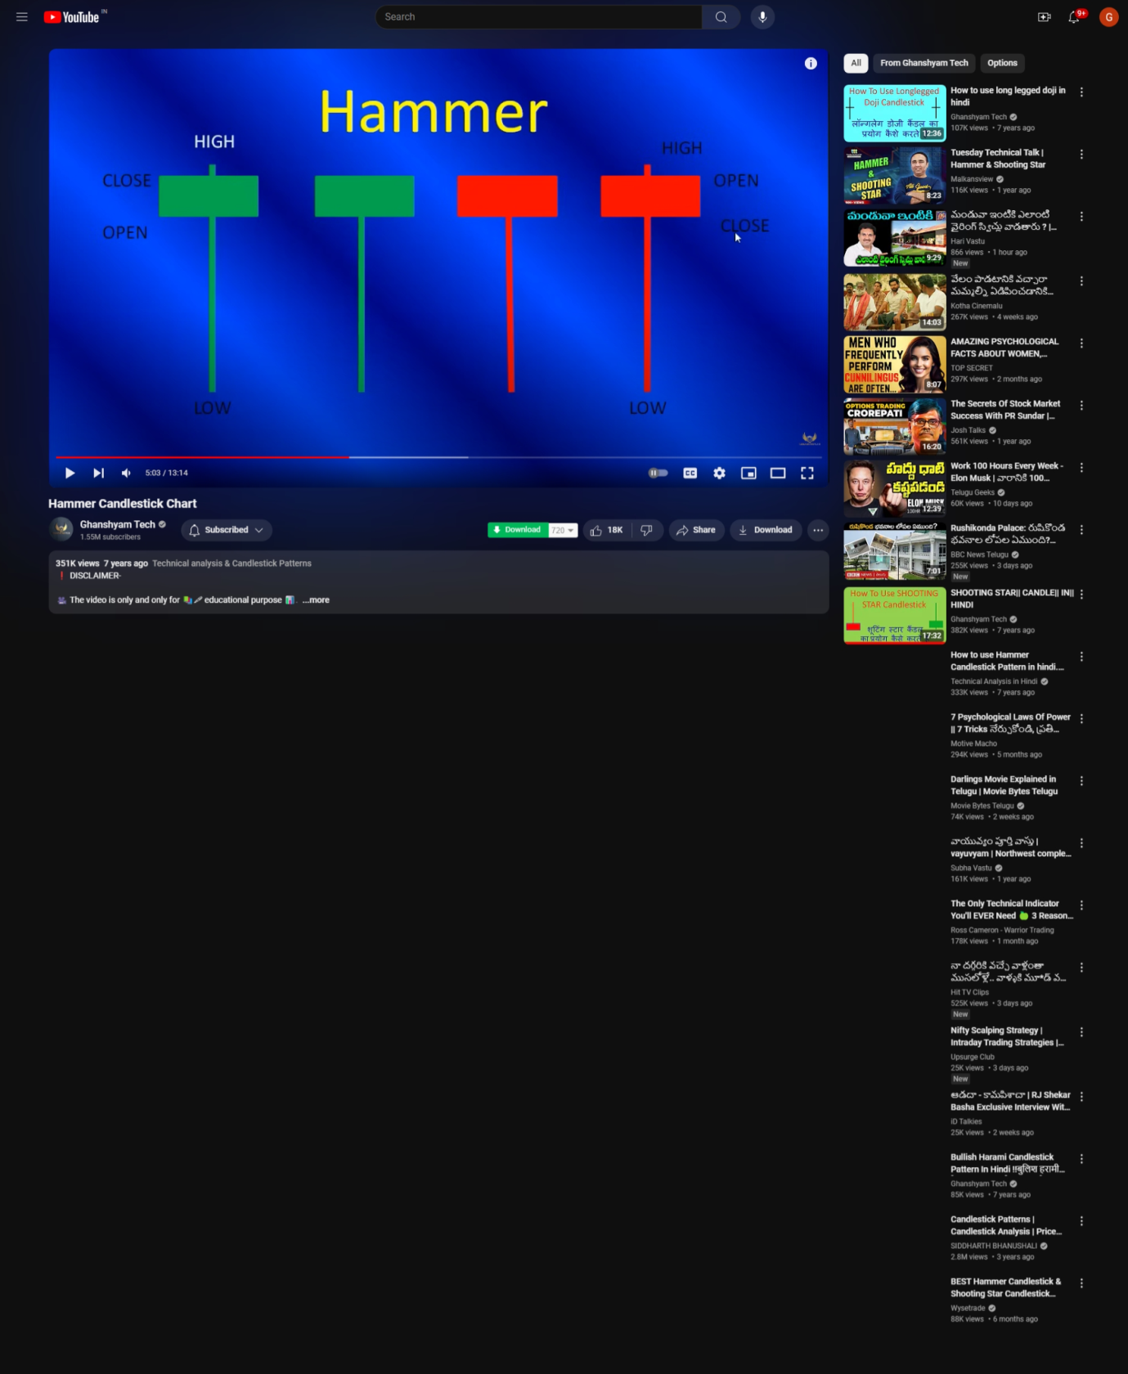

Small body at top with long downward wick and small wick at top or no wick that is high == close or open depending on color of hammer

Hammer will be efficient when hammer forms at bottom after min 10 downtrend candles or near CPR support or fib downtrend limits

**Green hamer will be more bullish than red

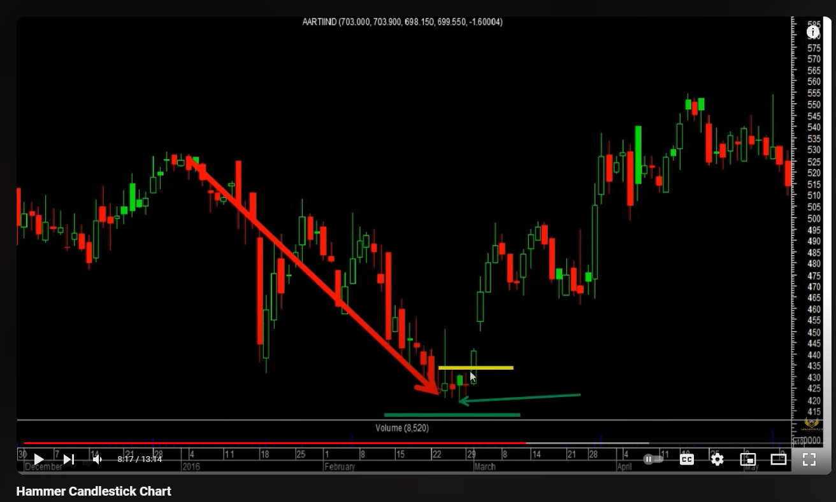

Entry of ce call buy for uptrend can be made when next candle formed after “hammer at the bottom of down trend and near to the support of CPR” next canle will open above the hammers open or close depending on the color / bullish or bearish hammer type

Green line is the entry point for CE CALL buy and green line is the stop loss

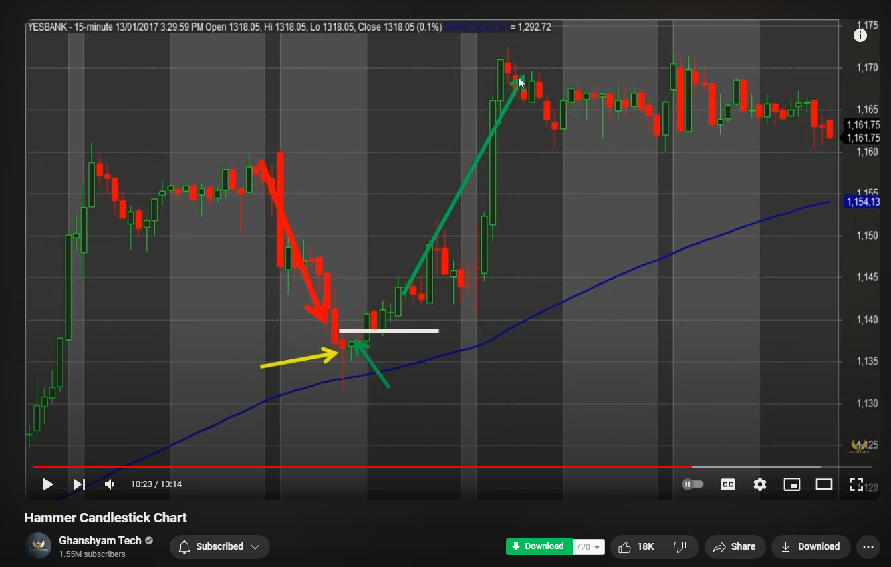

And sell/exit at the top near the cpr resistances and fib uptrend levels , before exit or sell order wait to see if next candle forms above the cpr resistance levels , if yes do not place sell order , if noe and trend reverses place the sell / exit order

# Inverted Hammer :-

Inverted Hammer is nothing but shooting star which is formed at the bottom of the bearish trend [shooting star formed at top of up trend signals start of bearish trend )start formed at the bottom )

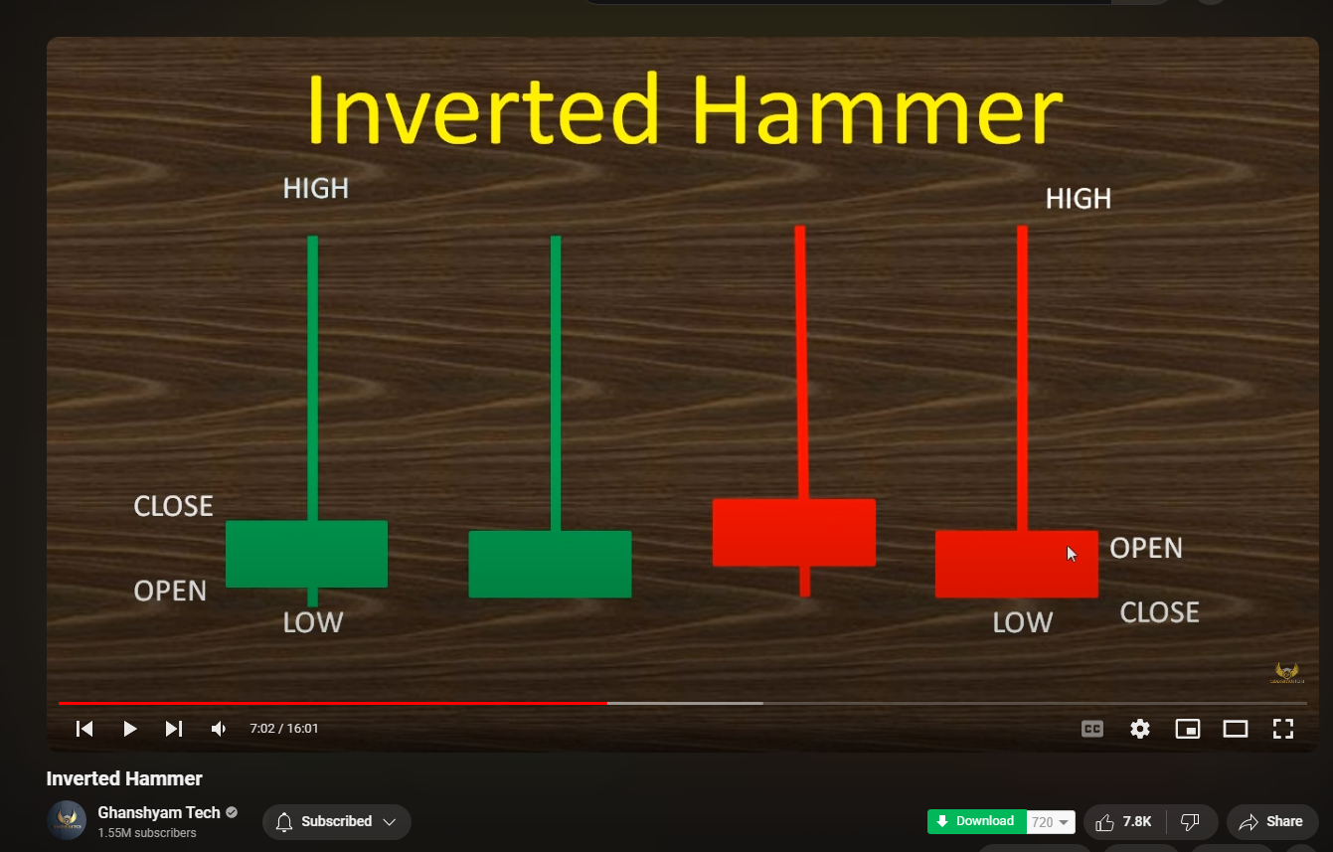

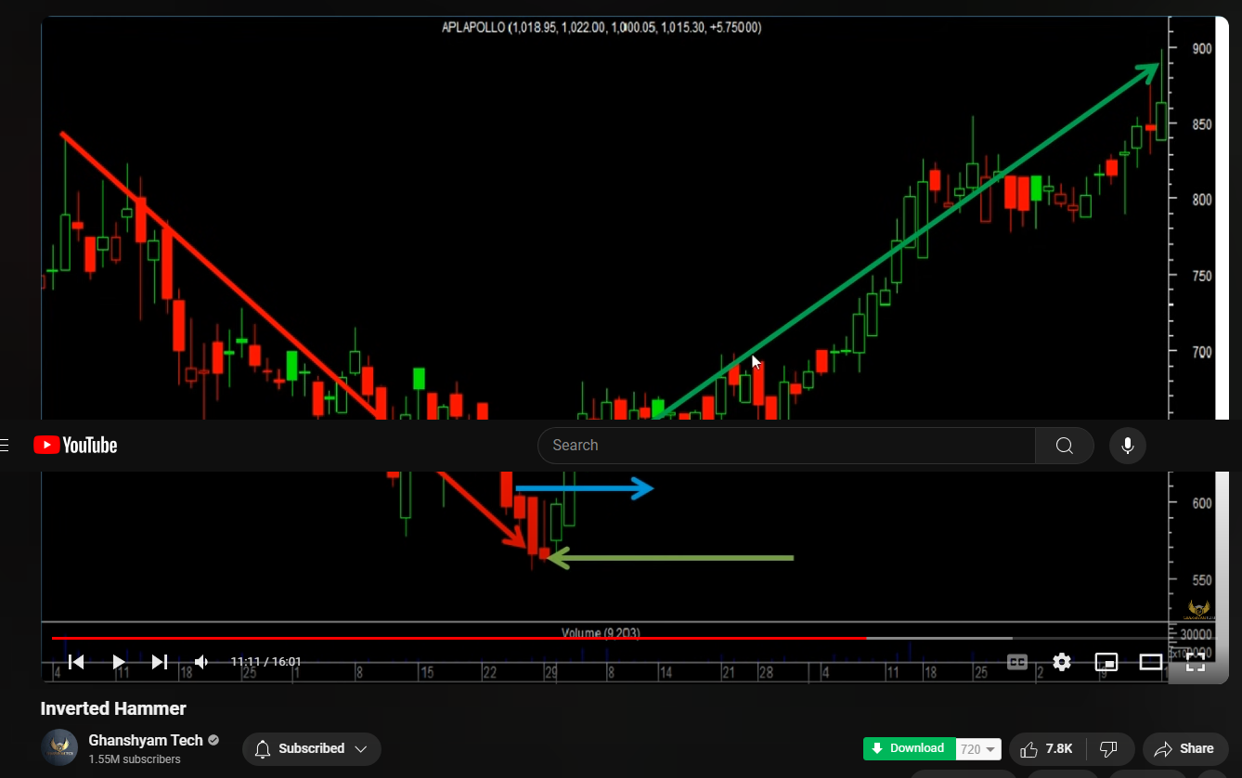

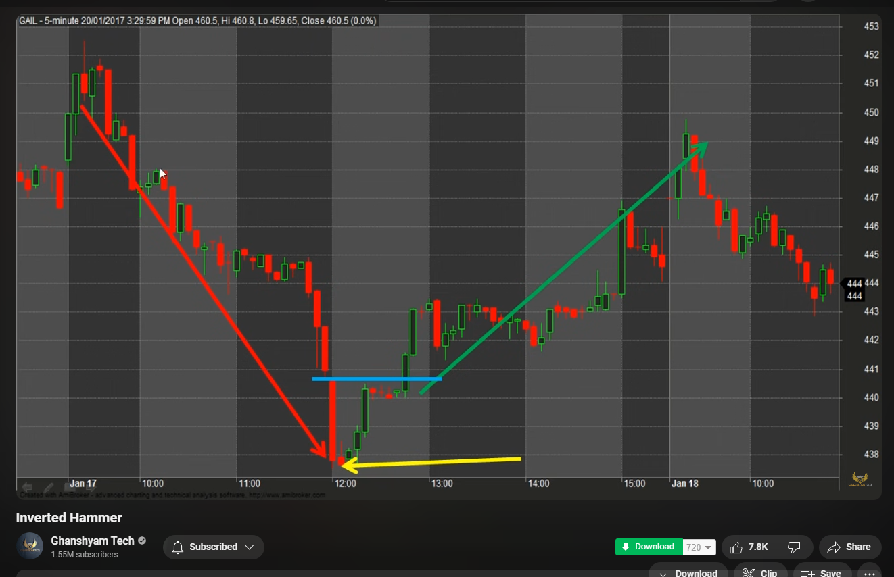

Candle which forms after inverted hammer should open with Gap from the inverted hammers open or close depending on the color of hammer which can be green for bullish inverted hammer and red for bearish inverted hammer ( look at the image above )

# Bullish Abandoned baby :-

It’s a doji candle ? always ?

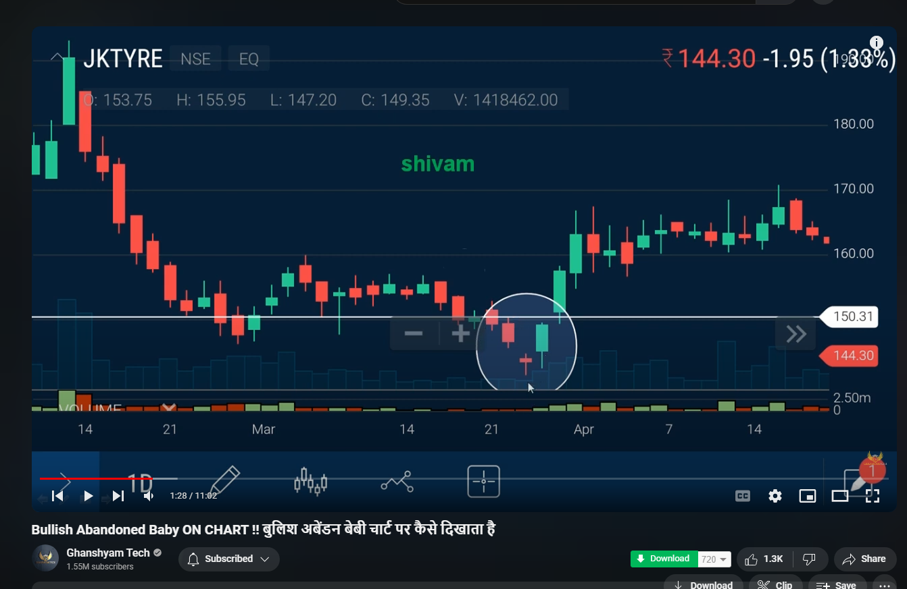

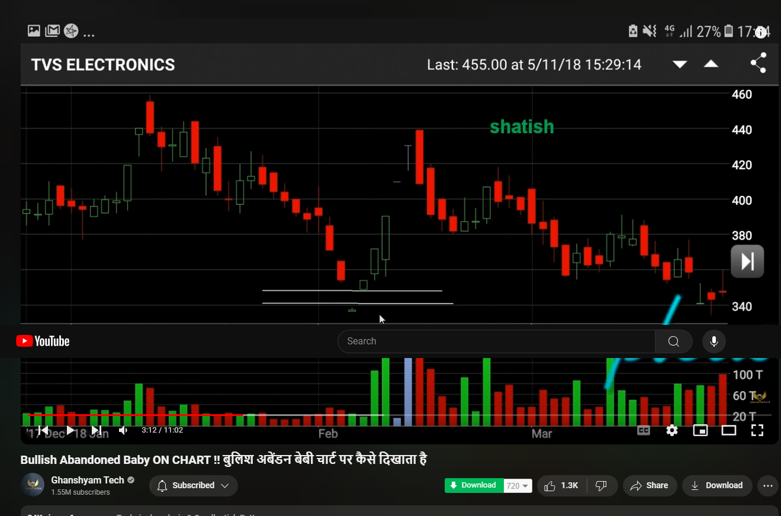

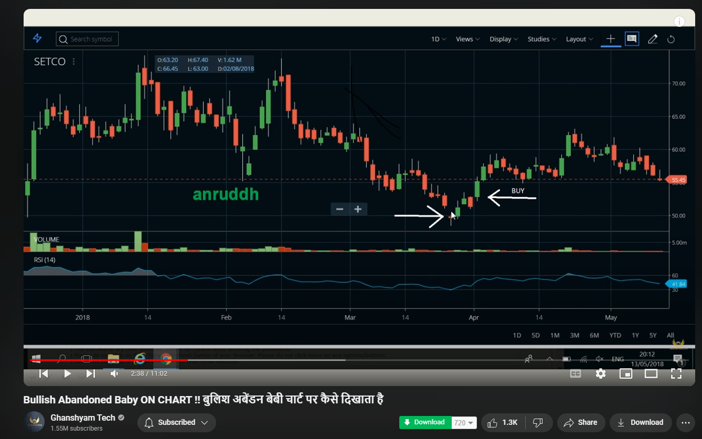

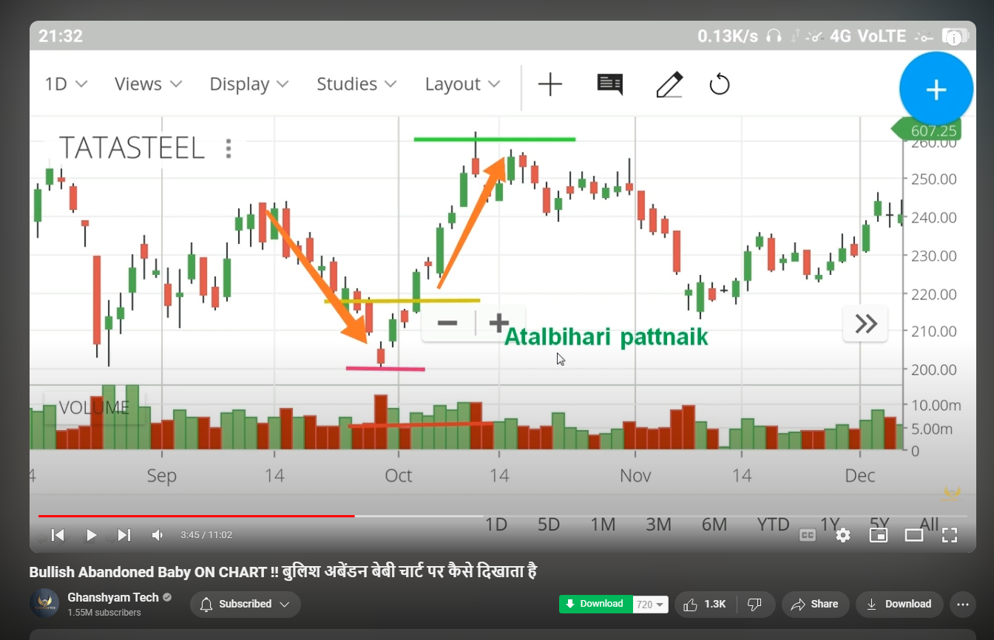

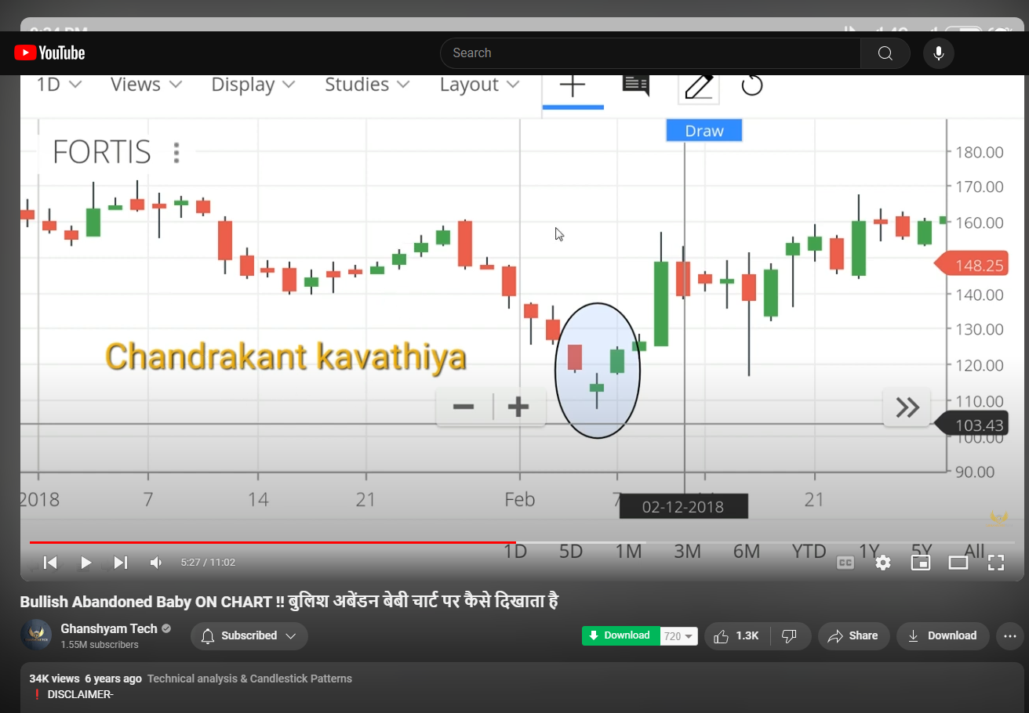

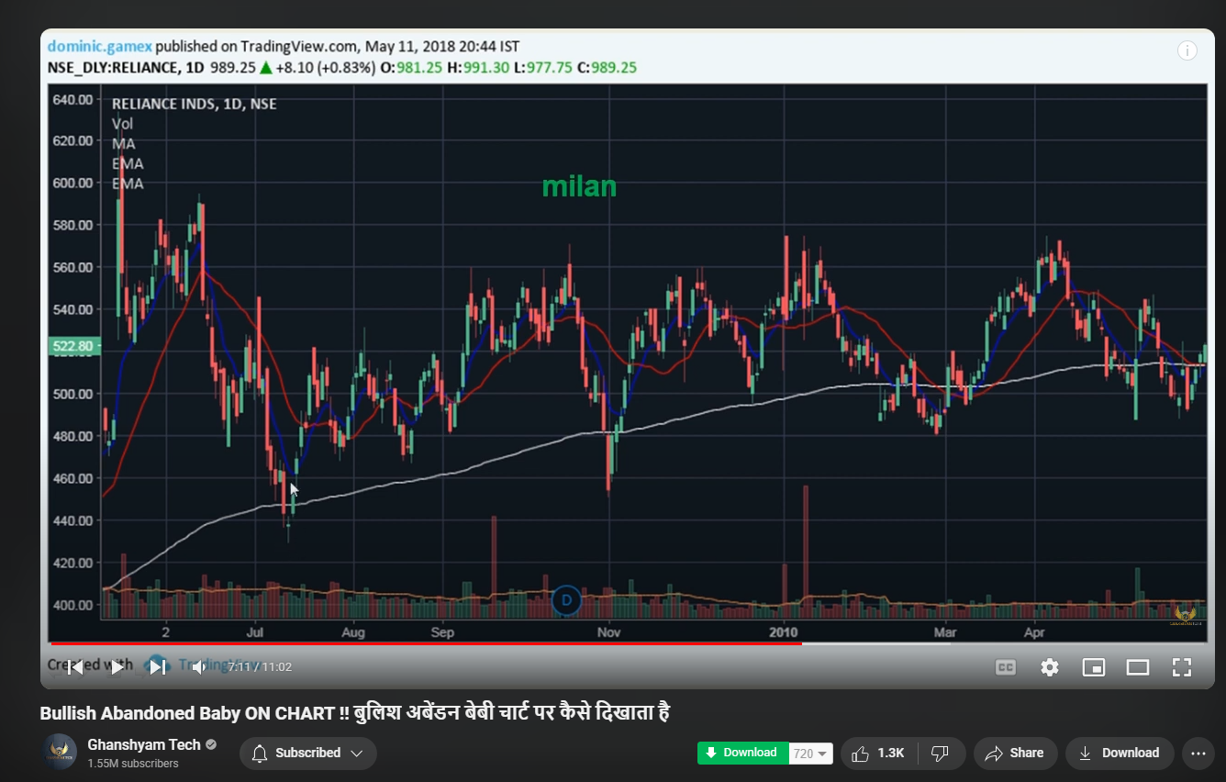

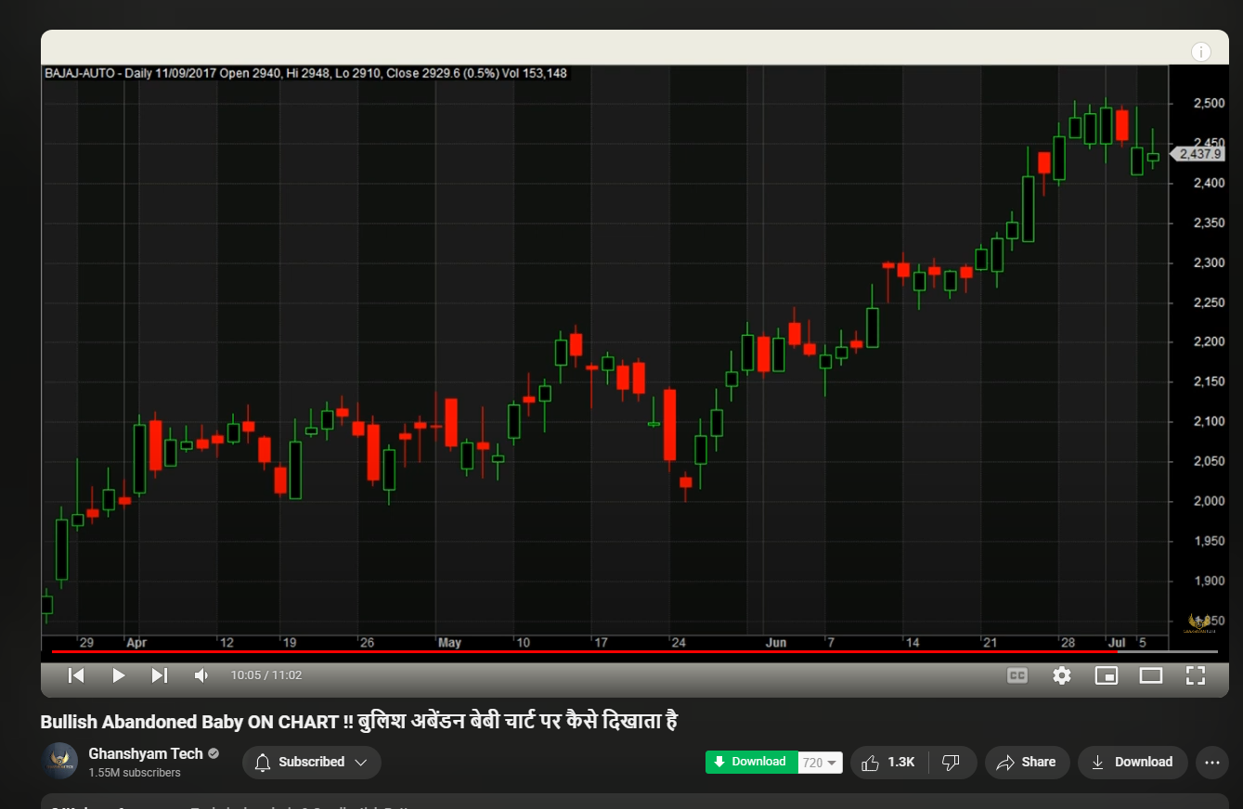

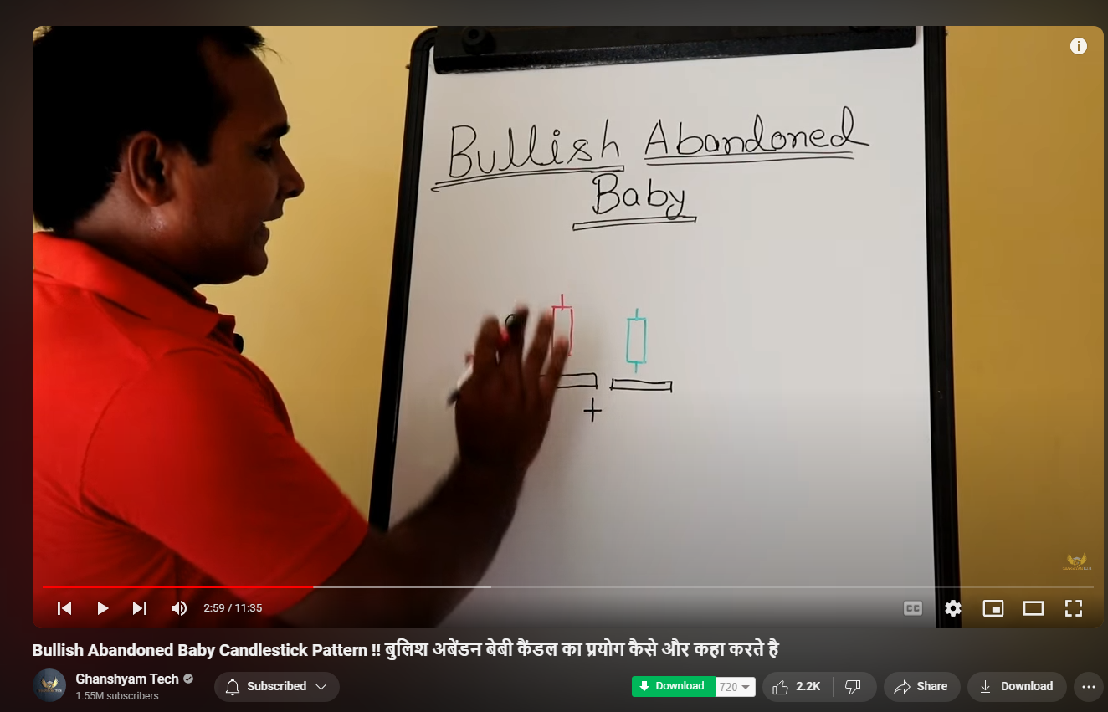

# Tweezer top pattern and tweezer bottom pattern :-

Top of red candle should not be high than top of green candle

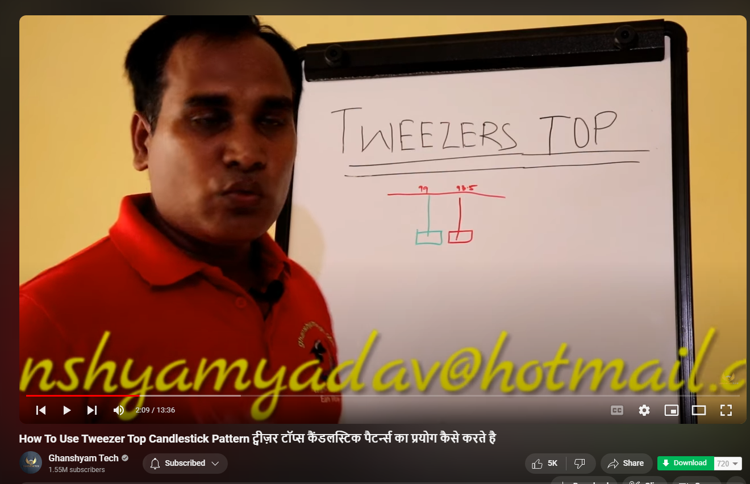



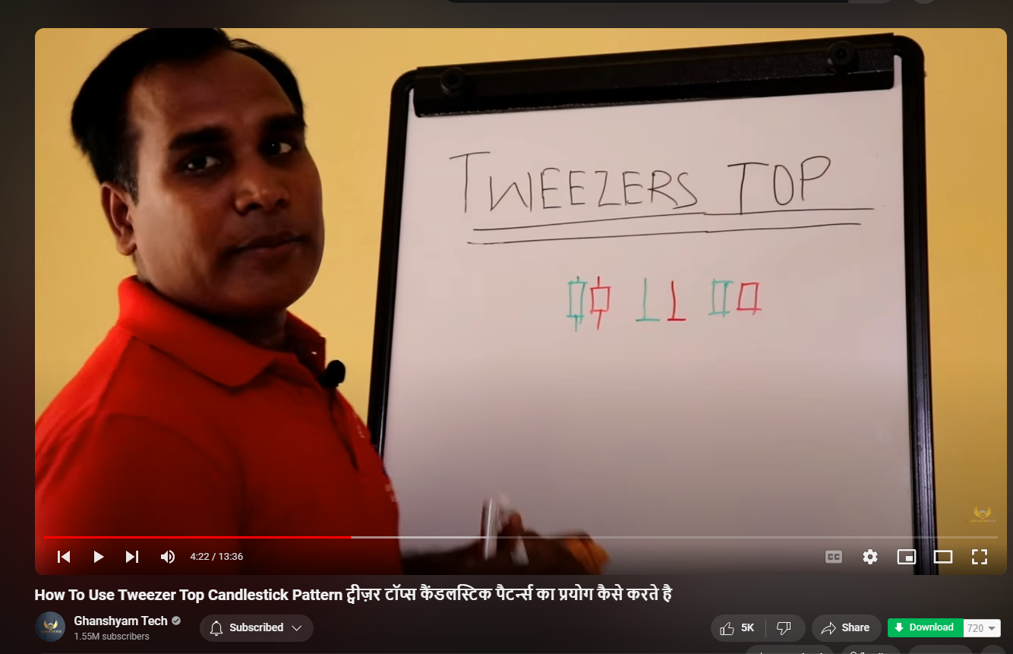

Doubtful not sure or my logic says not correct , but ghansham says --- during the formation of tweezer top there should not be a red candle during the uptrend which covers atleast two green candles , if that is the case the tweezer top may not work good or give expected results ( below image)’

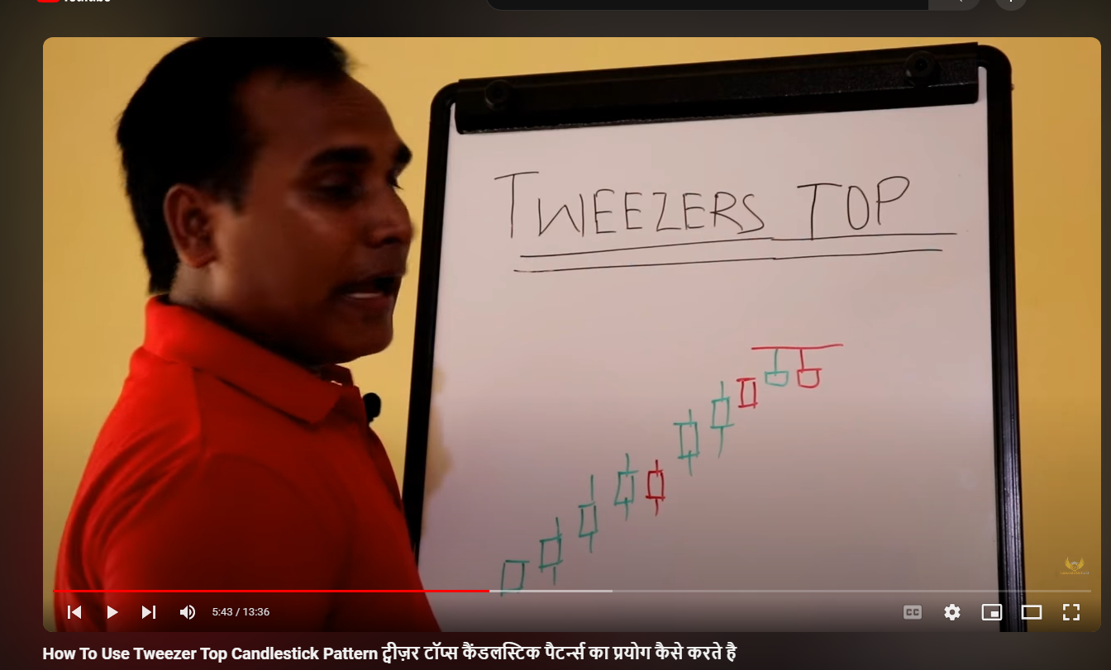

“According to him enter the trade if the latest candle formed is below the second tweezer top , but he says wait till the latest candle to complete / close below the 1 candle before the 1st tweezer top candle which is a sign of endof up trend “ ( check below image )

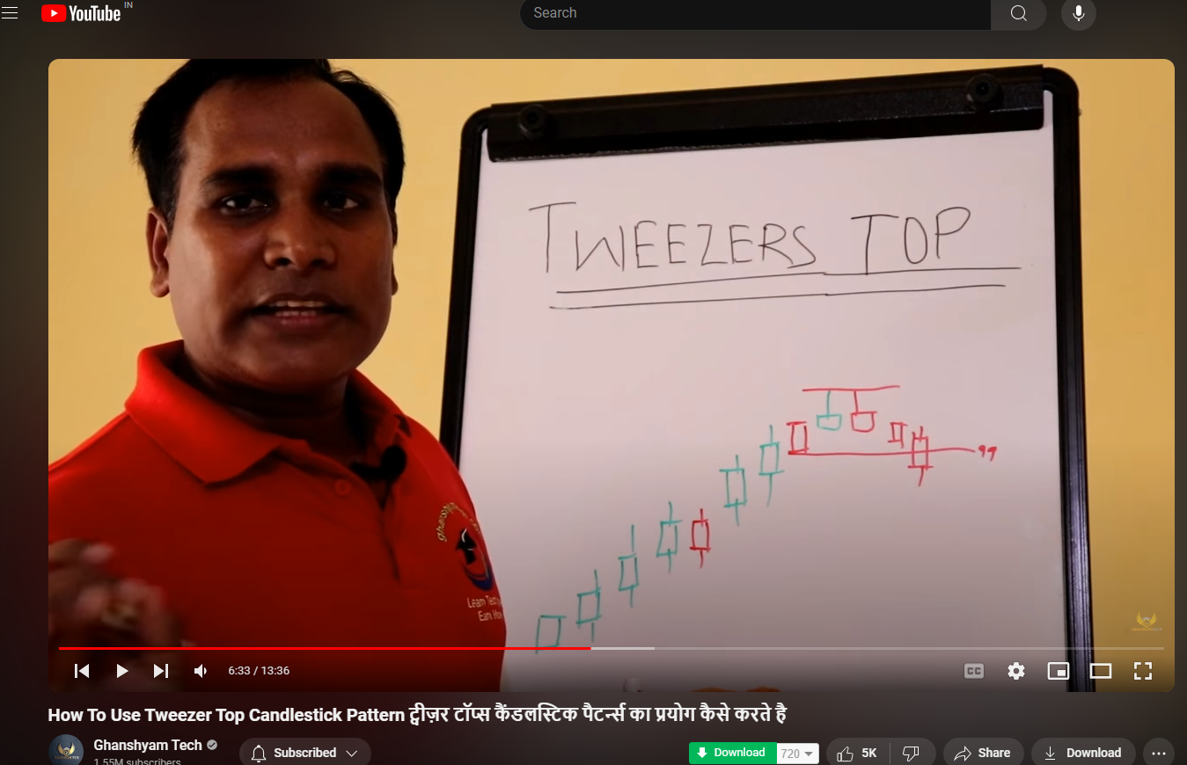

And target is two times the distance between the top point and the entry point ( note this is the distance of the index cabdles not options)

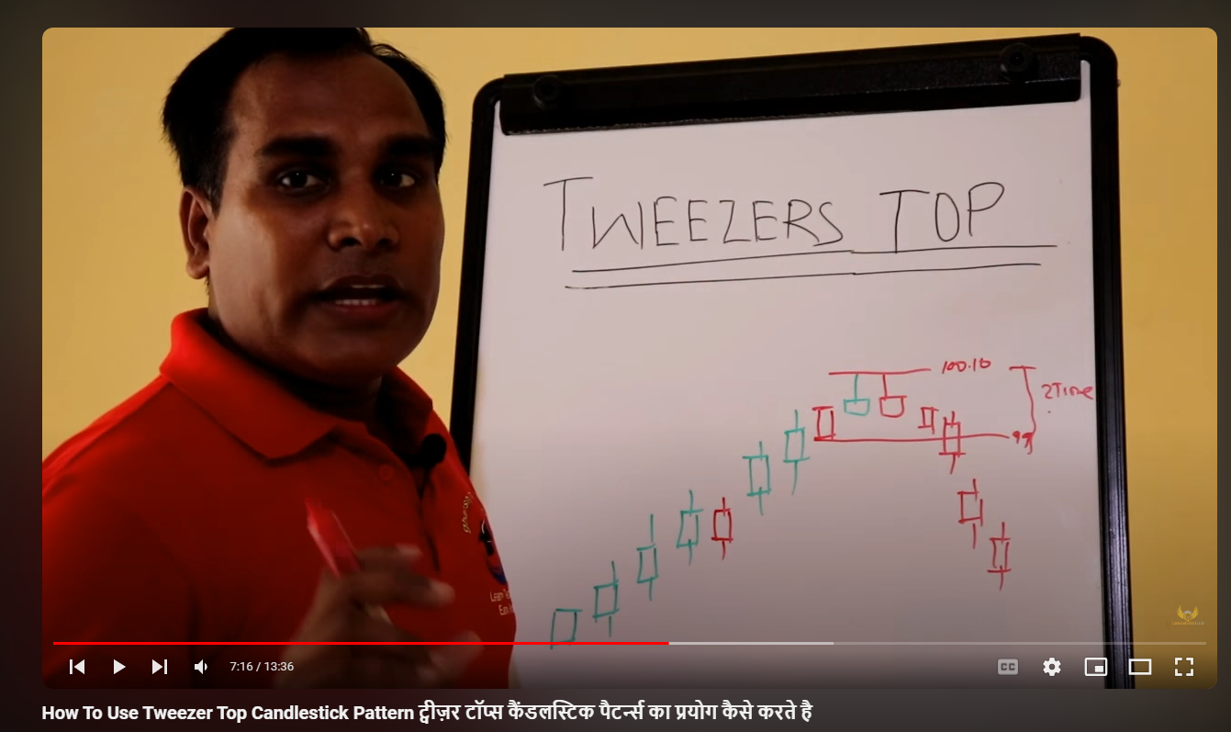

Stop loss / exit condition , if after three candles from the point of trade entry if the candles does not make lows than same depth / distance or points or double the from the point of entry then , this is a failure sign for this tweezer top and place a exit trade / sell order at mkt price

Note : low should be broken before three candles , we will exit even if the low is broken after third candle

That is exit the PE put buy order



Stop loss exit condition 2: if the any of the candle after tweezer top breaks the high then that will be the end of the trade ( PE BUY) trade ( check the image below )



# Tweezer bottom :-

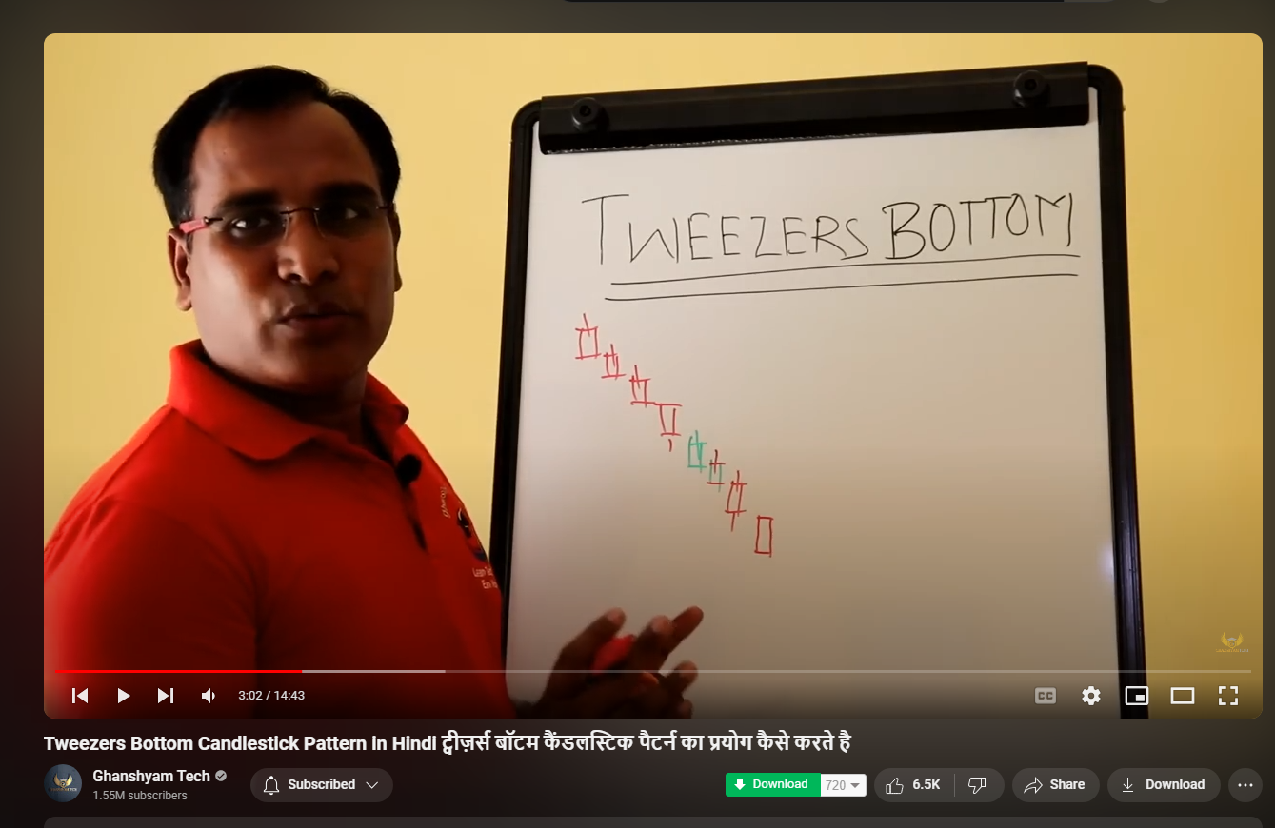

The bottom most candles which form should be both alike two morubozu or tow any other forms , but condition is first is red and second is green

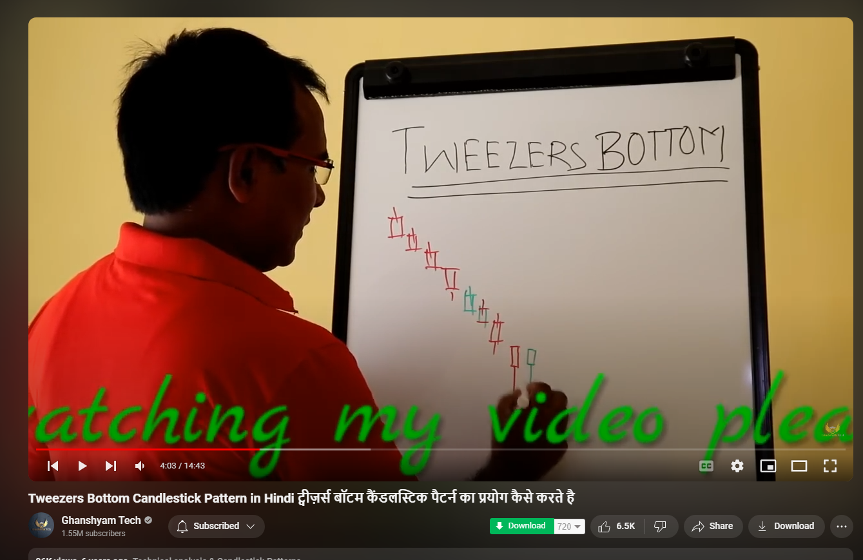

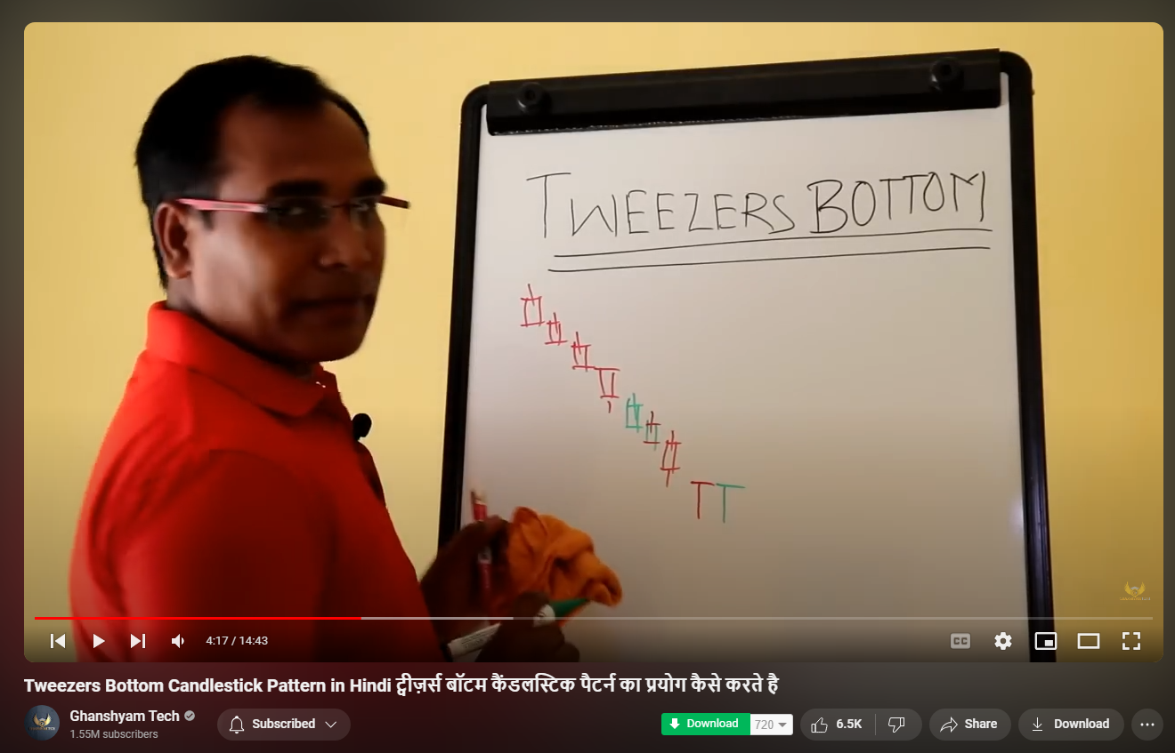

He says , buy the ce call only after any of the next candles break the high of the candle before tweezer bottom start candle (red candle) see image below

*** entry and sl 1: What I say is , enter trade immediately after seeing tweezer bottom , if first three candles after tweezer bottom second candle does not show bullish and break high of the candle before tweezer bottom start candle (red candle) then exit the trade (image below)

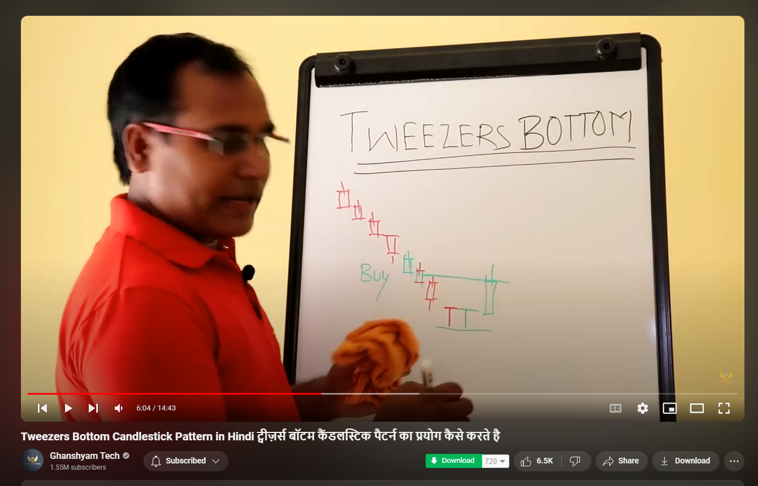

**** entry and sl 2: or if next candle after the 2nd tweezer bottom (green candle) breaks low of second candle then also exit trade( image below)

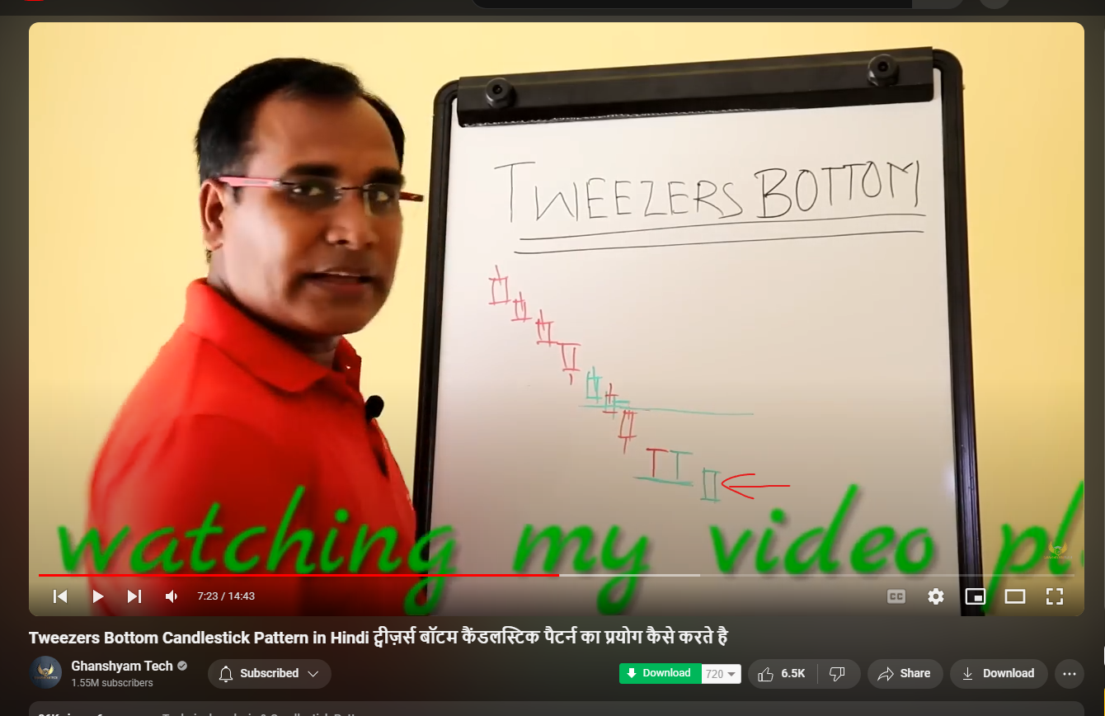

**trailing stop loss : And if the next candle break the high , but makes a low which is above the previous high and then start then continue , if breaks previous high , then exit trade

Tweezer bottom Entry condition double check : there should be continous red candles downward or one or two green candles but green candle should not be covering two or three red candles that formed earlier to it , there should not be any big green candle covering the multiple reds (like shown in the image below)

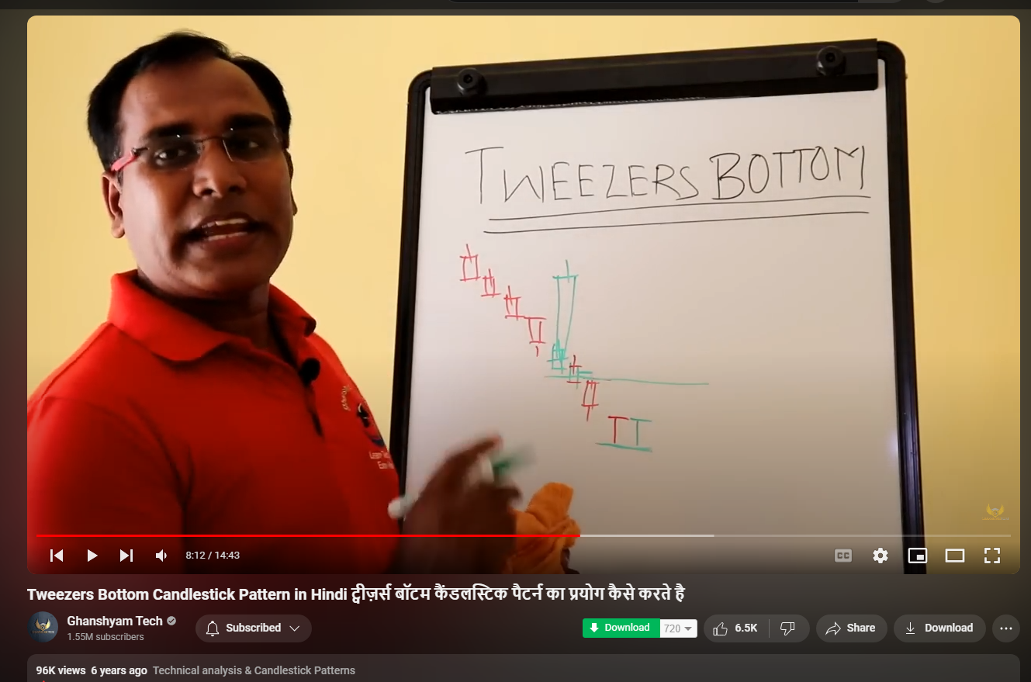

# =============pivots ===============

From bard ai

See the latest updates to the [Gemini Apps Privacy Hub Opens in a new window](https://support.google.com/gemini?p=privacy_help)

close

# Conversation with Gemini



## difference between CPR and Camarilla Pivot Points Calculation

volume_up

Both CPR (Central Pivot Range) and Camarilla Pivot Points are technical analysis tools used by traders to identify potential support and resistance levels in the market. However, they differ in their approach:

**CPR (Central Pivot Range):**

* Focuses on recent price action (High, Low, Close) of a single trading period (day, week, etc.)
* Calculation is relatively simple:
  + Pivot Point = (High + Low + Close) / 3
  + Top Central Pivot (TC) = (High + Low) / 2
  + Bottom Central Pivot (BC) = (Pivot Point - (High - Low)) + Pivot Point
* Provides 3 key levels: Pivot Point (potential support/resistance), TC (resistance), and BC (support)

**Camarilla Pivot Points:**

* Uses a more complex formula incorporating prior day's High, Low, and Close along with multiples of those values.
* Requires additional calculations for multiple support and resistance levels beyond the basic CPR points.
* Offers a wider range of potential price targets (typically 8 levels - 4 resistance, 4 support)

Here's a table summarizing the key differences:

|  |  |  |
| --- | --- | --- |
| **Feature** | **CPR** | **Camarilla Pivot Points** |
| Focus | Recent price action | Prior day's price & multiples |
| Calculation Complexity | Relatively simple | More complex |
| Levels Provided | 3 (Pivot, TC, BC) | 8 (4 resistance, 4 support) |

drive_spreadsheetExport to Sheets

**In simpler terms:**

* CPR is like a basic weather forecast based on yesterday's highs and lows.
* Camarilla Pivot Points are like an extended forecast with highs, lows, and chances of rain/sunshine at different times of the day.

**Choosing between CPR and Camarilla:**

* **CPR:** Easier to calculate, good for quick analysis of intraday support/resistance.
* **Camarilla:** More complex but offers a wider range of potential price targets.

Ultimately, the choice depends on your trading style and preferred level of detail.

share

more_vert



edit

## explain formula for cpr and cameriall

edit

Show drafts

volume_up

## CPR (Central Pivot Range) Formula

The CPR calculation involves three key levels: Pivot Point, Top Central Pivot (TC), and Bottom Central Pivot (BC). Here's how to find them:

1. **Pivot Point (P):**
   * P = (High + Low + Close) / 3
     + High, Low, and Close refer to the previous trading period's (day, week, etc.) prices.
2. **Top Central Pivot (TC):**
   * TC = (High + Low) / 2
3. **Bottom Central Pivot (BC):**
   * BC = (P - (High - Low)) + P
     + This formula essentially subtracts the difference between High and Low (previous day's price range) from the Pivot Point (P) and then adds P back to get the BC value.

## Camarilla Pivot Points Formula

Camarilla uses a more intricate formula compared to CPR. It incorporates the prior day's High (H), Low (L), and Close (C) along with multiples of these values to calculate multiple support and resistance levels. Here's a breakdown:

1. **Pivot Point (P):** (Same as CPR)
   * P = (High + Low + Close) / 3
2. **Resistance Levels (R1 to R4):**
   * R1 = (H - L) x 1.1 / 12 + C
   * R2 = (H - L) x 1.1 / 6 + C
   * R3 = (H - L) x 1.1 / 4 + C
   * R4 = (H - L) x 1.1 / 2 + C
3. **Support Levels (S1 to S4):**
   * S1 = C - (H - L) x 1.1 / 12
   * S2 = C - (H - L) x 1.1 / 6
   * S3 = C - (H - L) x 1.1 / 4
   * S4 = C - (H - L) x 1.1 / 2

**Note:**

* Remember, these are just the formulas.
* Financial calculators or trading platforms often have built-in features to calculate these pivot points automatically.

I hope this explanation clarifies the formulas for CPR and Camarilla Pivot Points!